# find Assignment

**Mandatory:**

1. Search and display all *.c and *.h files in all subdirectories starting from current directory

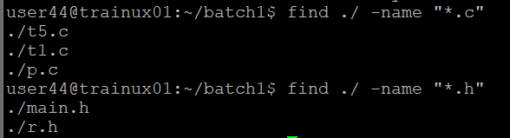

1. Search and display all directories in all subdirectories starting from current directory

Ans) use find . -type d ll

1. Search and display all files with permissions only rw with user and execute permission for others

Ans) find . -type f -perm 0601 - using numbers

find . -type f -perm -u=rw -perm -o=x

find . -type f -perm -u=rw,o=x